**5. Reactjs-HOL**

**Step 1.** Download and unzip the provided file

**Step 2.** Restore the node package using following command

**“npm install”**



**Step 3.** Create the CohortDetails.module.css file in src folder and write all the necessary code

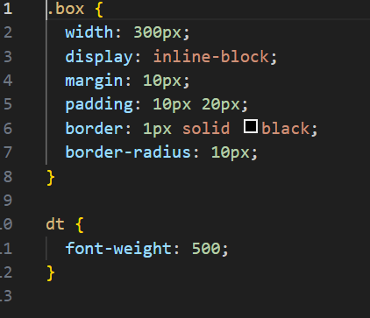

**Step 4.** Update the CohortDetails.js file and add conditional rendering formula

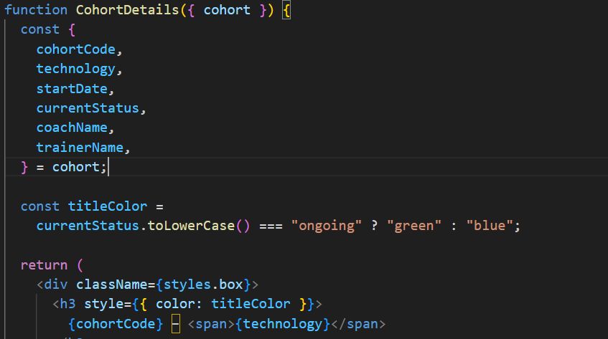

**Step 5**. Start the server by **“npm start”** command



**Output:-** Output should be something like this

